Whois Deployment Diagram

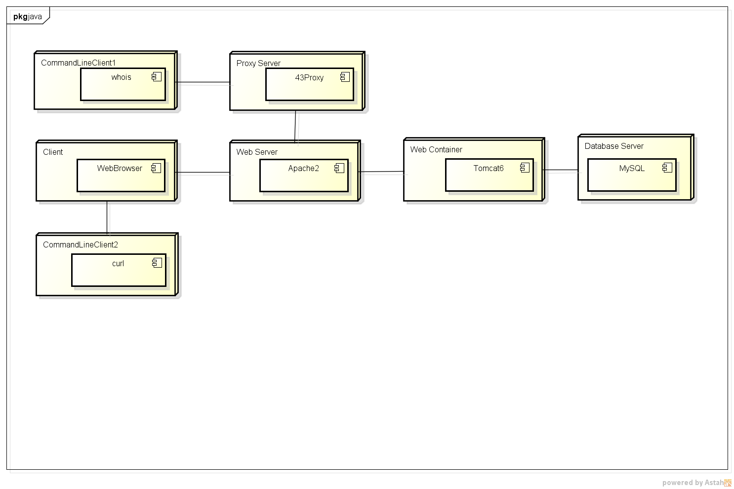

The figure depicts the framework of the project in the actual deployment of applications。The client has three forms of embodies, including the browser and the command prompt window. Client Appache access to tomcat application.